**Lab 2 DNS**

**Objectives**

As described in Section 2.4 of the textbook, the Domain Name System (DNS) translates hostnames to IP addresses, fulfilling a critical role in the Internet infrastructure. In this lab, we’ll take a closer look at the client side of DNS. Recall that the client’s role in the DNS is relatively simple – a client sends a *query* to its local DNS server, and receives a *response* back. As shown in Figures 2.19 and 2.20 in the textbook, much can go on “under the covers,” invisible to the DNS clients, as the hierarchical DNS servers communicate with each other to either recursively or iteratively resolve the client’s DNS query. From the DNS client’s standpoint, however, the protocol is quite simple – a query is formulated to the local DNS server and a response is received from that server.

**Procedures**

Before beginning this lab, please first review DNS by reading Section 2.4 of the textbook. In particular, you may want to review the material on **local DNS servers**, **DNS caching**, **DNS records and messages**, and the **TYPE field** in the DNS record.

1. nslookup

In this lab, we’ll make extensive use of the *nslookup* tool, which is available in most Linux/Unix and Microsoft platforms today. To run *nslookup* in Linux/Unix, you just type the *nslookup* command on the command line. To run it in Windows, open the Command Prompt and run *nslookup* on the command line.

In it is most basic operation, *nslookup* tool allows the host running the tool to query any specified DNS server for a DNS record. The queried DNS server can be a root DNS server, a top-level-domain DNS server, an authoritative DNS server, or an intermediate DNS server (see the textbook for definitions of these terms). To accomplish this task, *nslookup* sends a DNS query to the specified DNS server, receives a DNS reply from that same DNS server, and displays the result.

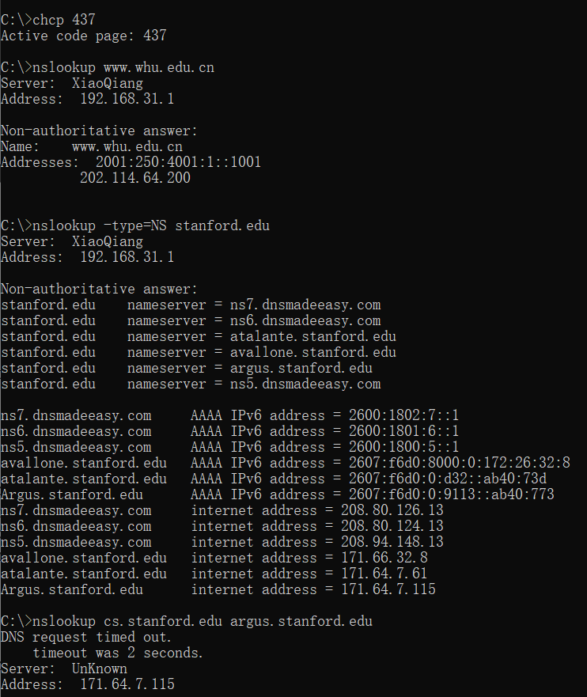

The above screenshot shows the results of several independent commands (displayed in the Windows Command Prompt). The first command line chcp 437 is to change the displaying code page of the Windows Command Prompt to code page 437. This command will set the terminal to display results of all input commands in English characters.

Except the first line, all the other followed commands are *nslookup* commands. In this example screen shot, the client host is in a home network located in Wuhan City, where the default local DNS server is of IP address 192.168.31.1(with server name XiaoQiang), configured by the Xiaomi smart router of the home network. When running *nslookup*, if no DNS server is specified, then *nslookup* sends the query to the default DNS server, which in this case is XiaoQiang. Consider the second command:

nslookup www.whu.edu.cn

In words, this command is saying “please send me the IP address for the host www.whu.edu.cn”. As shown in the screenshot, the response from this command provides two pieces of information: (1) the name and IP address of the DNS server that provides the answer; and (2) the answer itself, which is the host name and IP address of www.whu.edu.cn. Although the response came from the local DNS server, it is quite possible that this local DNS server iteratively contacted several other DNS servers to get the answer, as described in Section 2.4 of the textbook.

Now consider the third command:

nslookup –type=NS stanford.edu

In this example, we have provided the option “-type=NS” and the domain “stanford.edu”. This causes *nslookup* to send a query for a type-NS record to the default local DNS server. In words, the query is saying, “please send me the host names of the authoritative DNS for stanford.edu”. (When the –type option is not used, *nslookup* uses the default, which is to query for type A records.) The answer, displayed in the above screenshot, first indicates the DNS server that is providing the answer (which is the default local DNS server) along with six Stanford nameservers. Each of these servers is indeed an authoritative DNS server for the hosts on the Stanford campus, three of these six servers use dynamic DNS hosting service provided by dnsmadeeasy.com. However, *nslookup* also indicates that the answer is “non-authoritative,” meaning that this answer came from the cache of some server rather than from an authoritative Stanford DNS server. Finally, the answer also includes the IP addresses of the authoritative DNS servers at Stanford. (Even though the type-NS query generated by *nslookup* did not explicitly ask for the IP addresses, the local DNS server returned these “for free” and *nslookup* displays the result.)

Now finally consider the fourth command:

nslookup cs.stanford.edu argus.stanford.edu

In this example, we indicate that we want to the query sent to the DNS server argus.stanford.edu rather than to the default DNS server. Thus, the query and reply transaction takes place directly between our querying host and argus.stanford.edu. In this example, the DNS server argus.stanford.edu provides the IP address of the host cs.stanford.edu.

Now that we have gone through a few illustrative examples, you are perhaps wondering about the general syntax of *nslookup* commands. The syntax is:

nslookup –option1 –option2 host-to-find dns-server

In general, *nslookup* can be run with zero, one, two or more options. And as we have seen in the above examples, the dns-server is optional as well; if it is not supplied, the query is sent to the default local DNS server.

Now that we have provided an overview of *nslookup*, it is time for you to test drive it yourself. Do the following (and write down the results):

1. Run *nslookup* to obtain the IP address of a Web server in China. What is the IP address of that server?

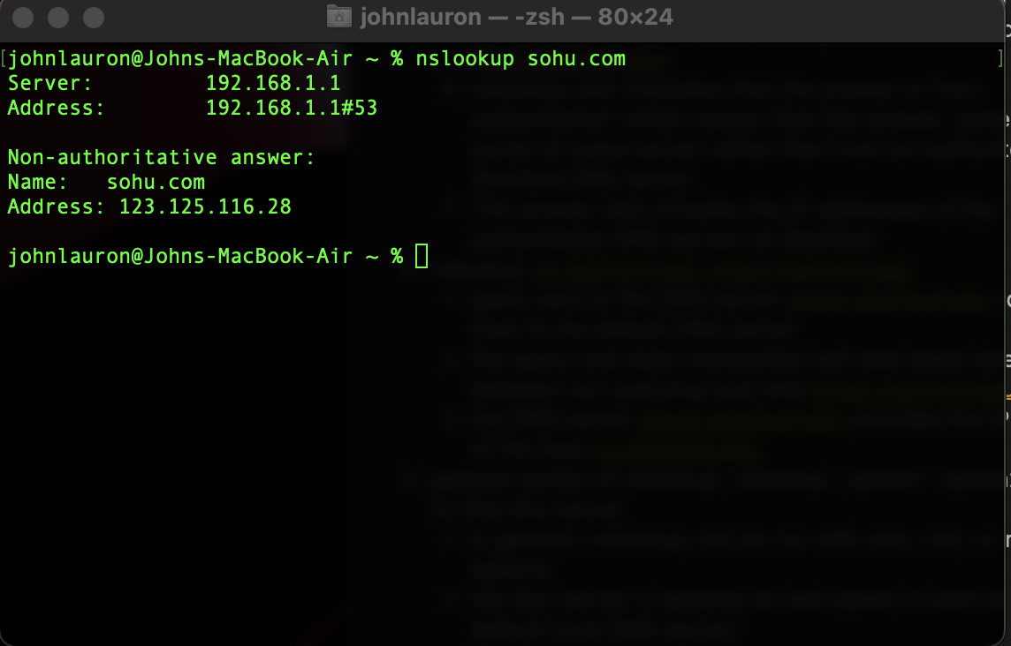

**The IP address of the server is 123.125.116.28 (https://www.sohu.com)**

1. Run *nslookup* to determine the authoritative DNS servers for a university in Europe.

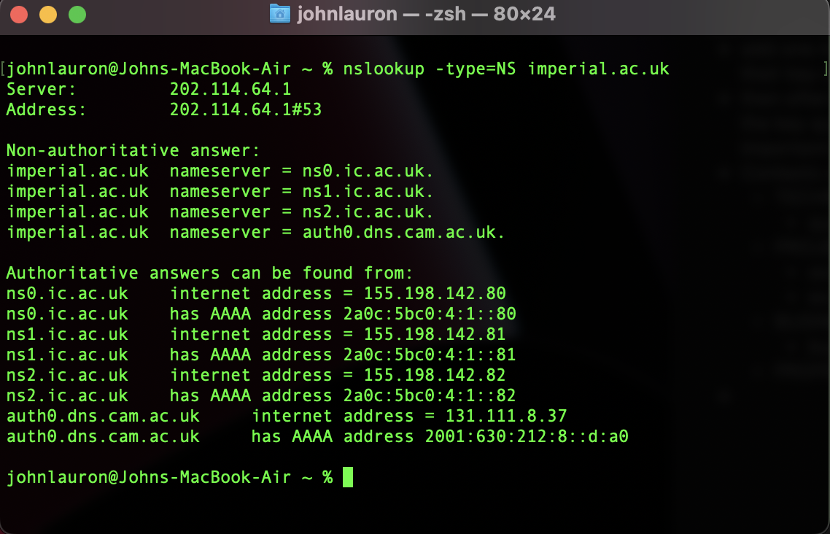

**The master DNS server is “ns0.imperial.ac.uk” and the remaining authoritative DNS servers are:**

**ns1.ic.ac.uk**

**ns2.ic.ac.uk**

**auth0.dns.cam.ac.uk**

1. Run *nslookup* so that one of the DNS servers obtained in Question 2 is queried for the mail servers for Yahoo! mail. What is its IP address?

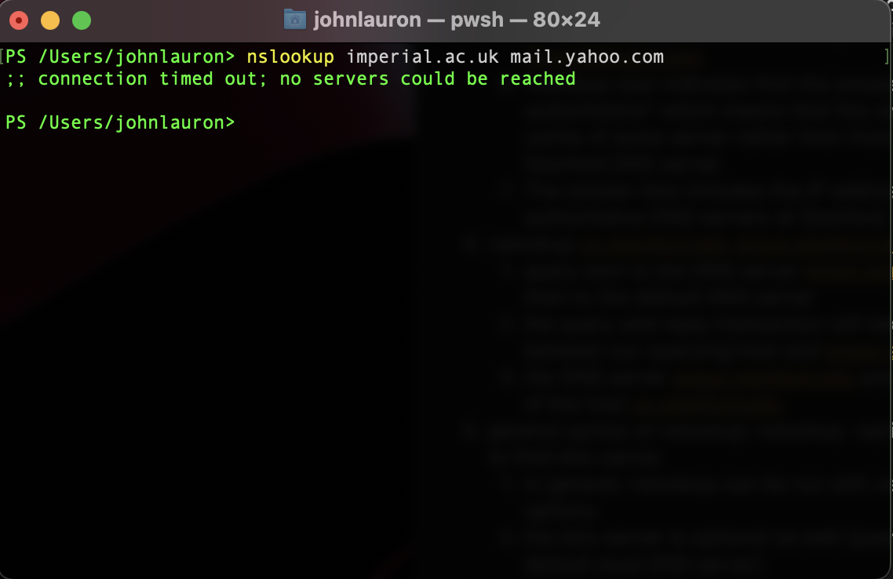

2. ipconfig

*ipconfig* (for Windows) and *ifconfig* (for Linux/Unix) are among the most useful little utilities in your host, especially for debugging network issues. Here we’ll only describe *ipconfig*, although the Linux/Unix *ifconfig* is very similar. *ipconfig* can be used to show your current TCP/IP information, including your address, DNS server addresses, adapter type and so on. For example, if you all this information about your host simply by entering

ipconfig /all

into the Command Prompt, as shown in the following screenshot.

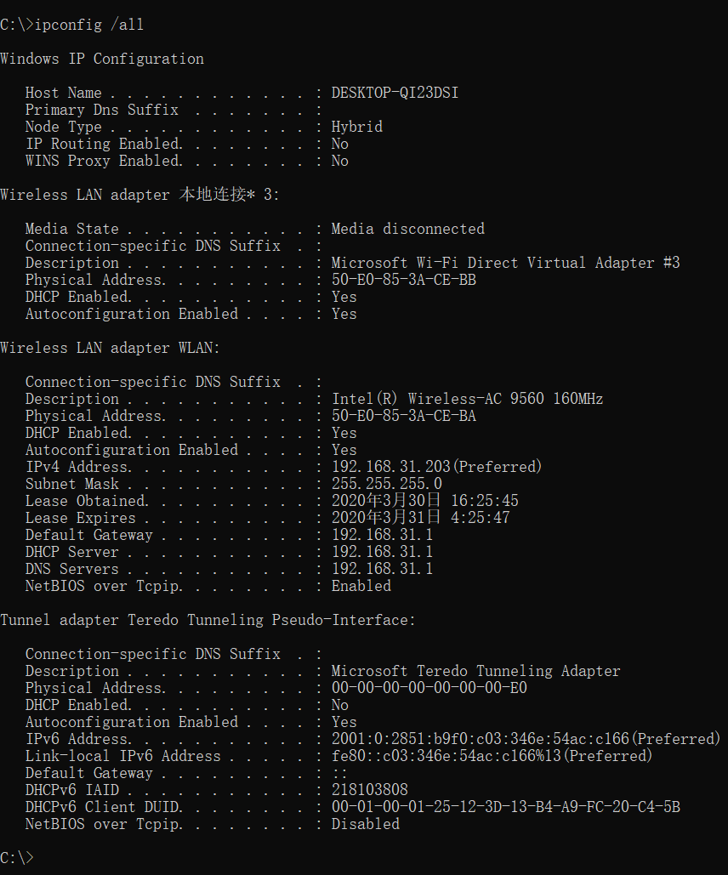

*ipconfig* is also very useful for managing the DNS information stored in your host. In Section 2.5 we learned that a host can cache DNS records it recently obtained. To see these cached records, after the prompt C:\> provide the following command:

ipconfig /displaydns

Each entry shows the remaining Time to Live (TTL) in seconds. To clear the cache, enter

ipconfig /flushdns

Flushing the DNS cache clears all entries and reloads the entries from the hosts file.

3. Tracing DNS with Wireshark

Now that we are familiar with *nslookup* and *ipconfig*, we’re ready to get down to some serious business. Let’s first capture the DNS packets that are generated by ordinary Web-surfing activity.

* Use *ipconfig* to empty the DNS cache in your host.
* Open your browser and empty your browser cache.
* Open Wireshark and enter “ip.addr == your_IP_address” into the filter, where you obtain your_IP_address with ipconfig. This filter removes all packets that neither originate nor are destined to your host.
* Start packet capture in Wireshark.
* With your browser, visit the Web page: http://www.ietf.org
* Stop packet capture.

Answer the following questions. Whenever possible, when answering a question below, you should print to file the packet(s) within the trace that you used to answer the question asked. Annotate the printout[1] to explain your answer. To print a packet, use *File->Print*, choose *Selected packet only*, choose *Packet summary line,* and select the minimum amount of packet detail that you need to answer the question.

1. Locate the DNS query and response messages. Are they sent over UDP or TCP?

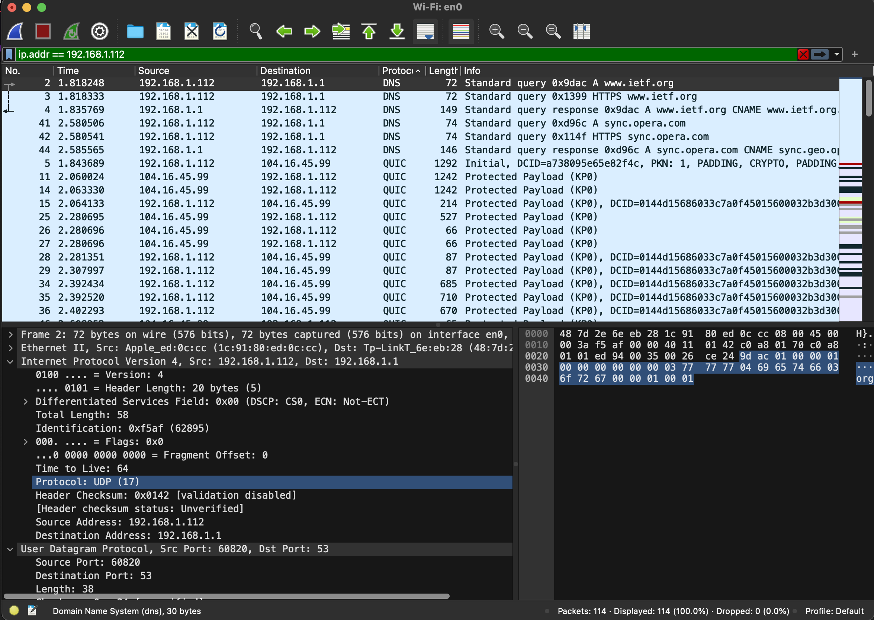

**They are sent over UDP.**

1. What is the destination port for the DNS query message? What is the source port of DNS response message?

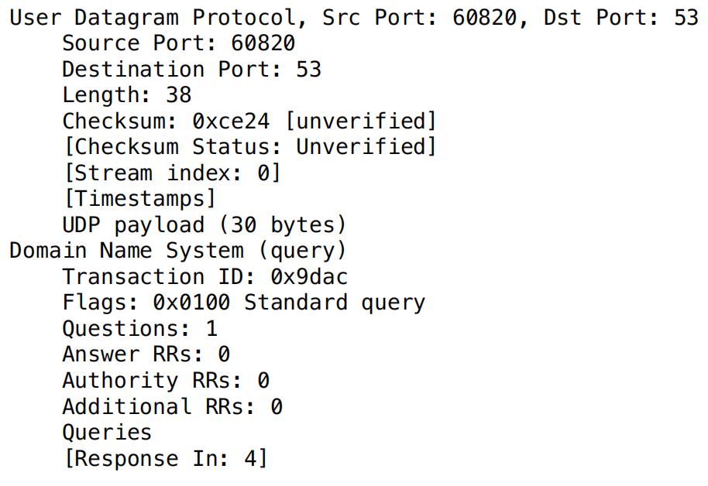

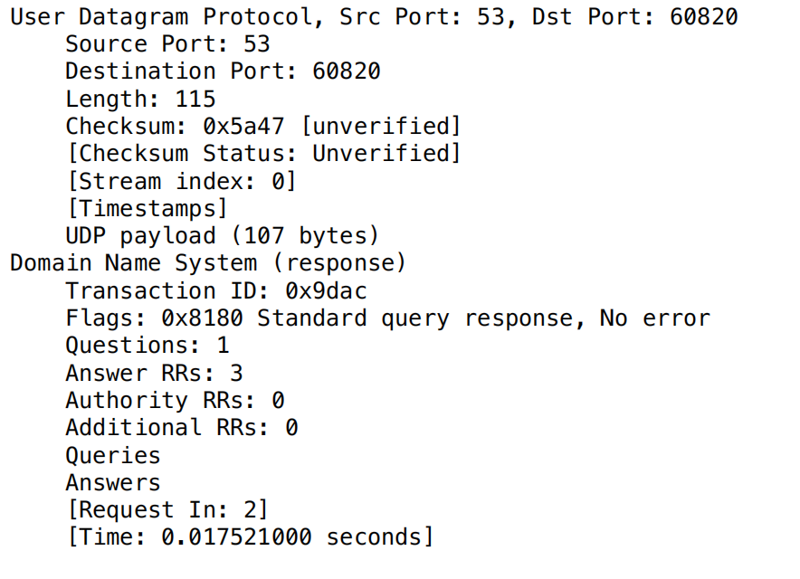

**The destination port for the DNS query message is 53 and the source port of the DNS response message is also 53.**

1. To what IP address is the DNS query message sent? Use ipconfig to determine the IP address of your local DNS server. Are these two IP addresses the same?

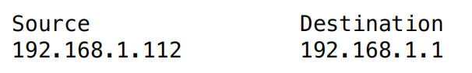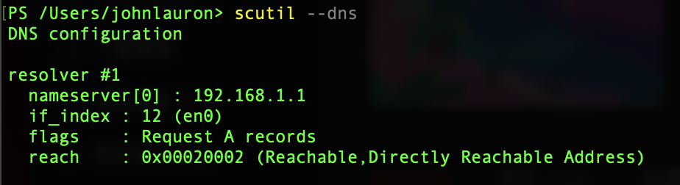

**The IP address was sent to 192.168.1.1. Yes, the IP address of my local DNS server and the IP address that the DNS query message was sent to is the same.**

1. Examine the DNS query message. What “Type” of DNS query is it? Does the query message contain any “answers”?

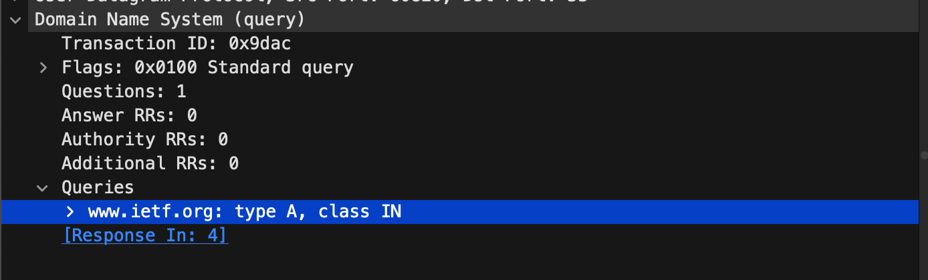

**It is a DNS query of Type A and it does not contain any “answers”.**

1. Examine the DNS response message. How many “answers” are provided? What do each of these answers contain?

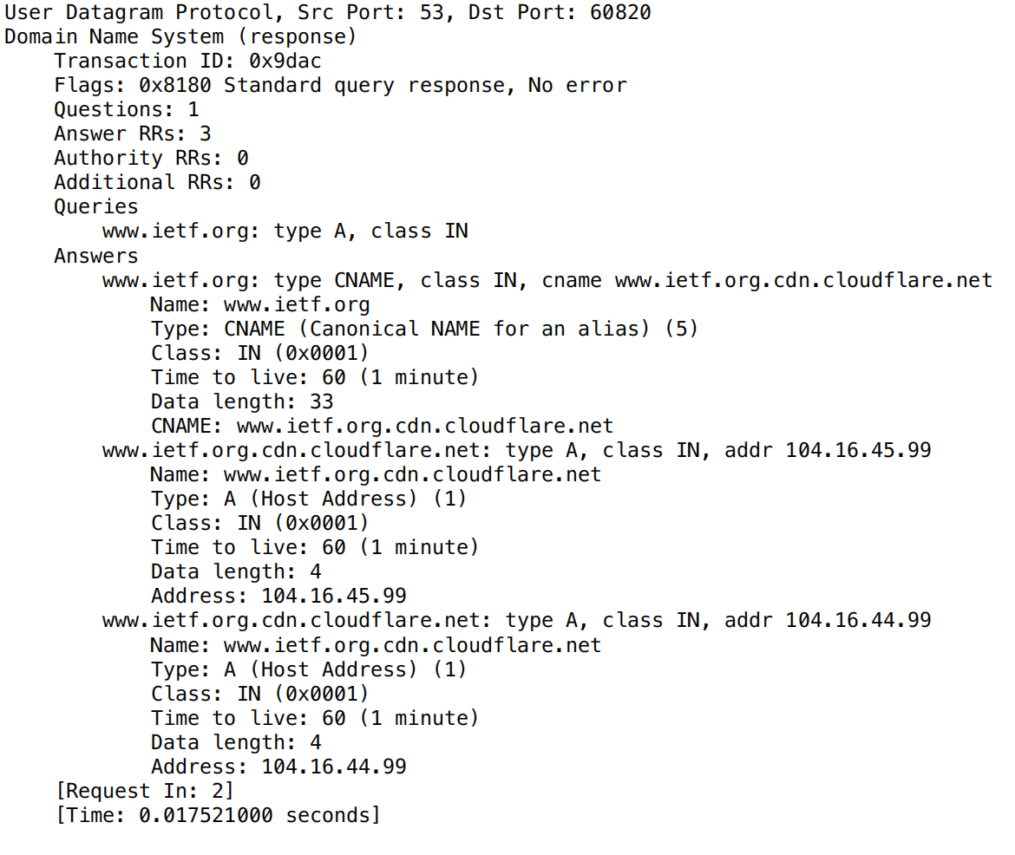

**There are 3 “answers” provided by the DNS response message. Each of the answers contain a Name, Type, Class, Time to live, Data length, CNAME (for the first answer), and Address (for the last two answers).**

1. Consider the subsequent TCP SYN packet sent by your host. Does the destination IP address of the SYN packet correspond to any of the IP addresses provided in the DNS response message?

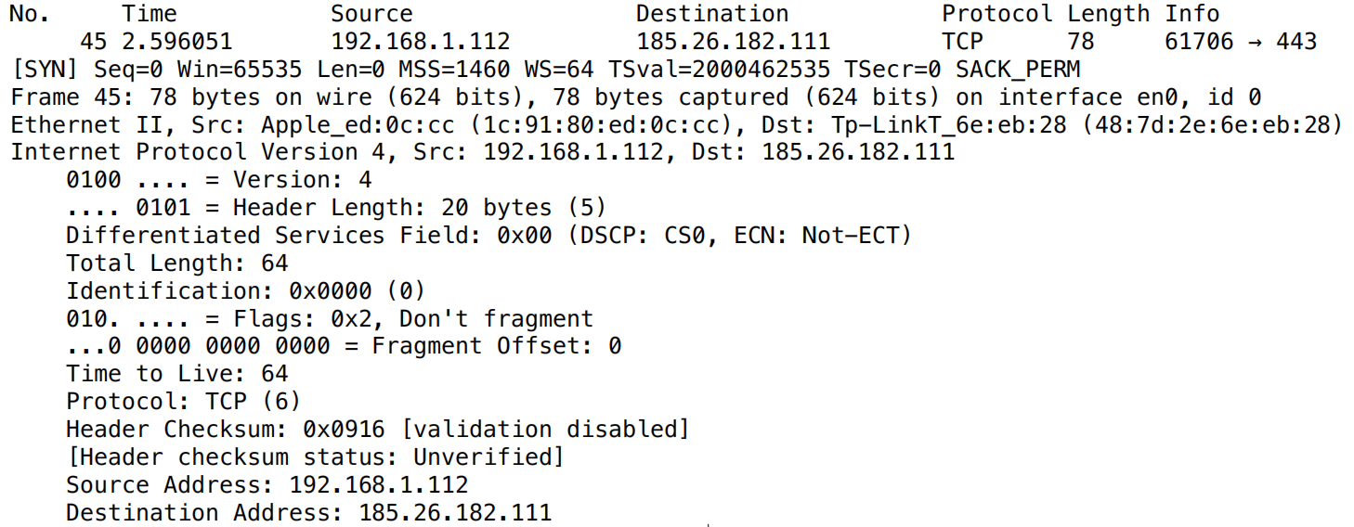

**No, none of the SYN packets correspond to any of the IP addresses provided in the DNS response message. The SYN packet’s destination address goes to 185.26.182.111. Only the TCP [FIN, ACK]packets correspond to 104.16.45.99 and 104.16.44.99 (the addresses provided in the DNS response message).**

1. This web page contains images. Before retrieving each image, does your host issue new DNS queries?

**No**

Now let’s play with *nslookup*.

* Start packet capture.
* Do an *nslookup* on www.stanford.edu
* Stop packet capture.

You should get a trace that looks something like the following: 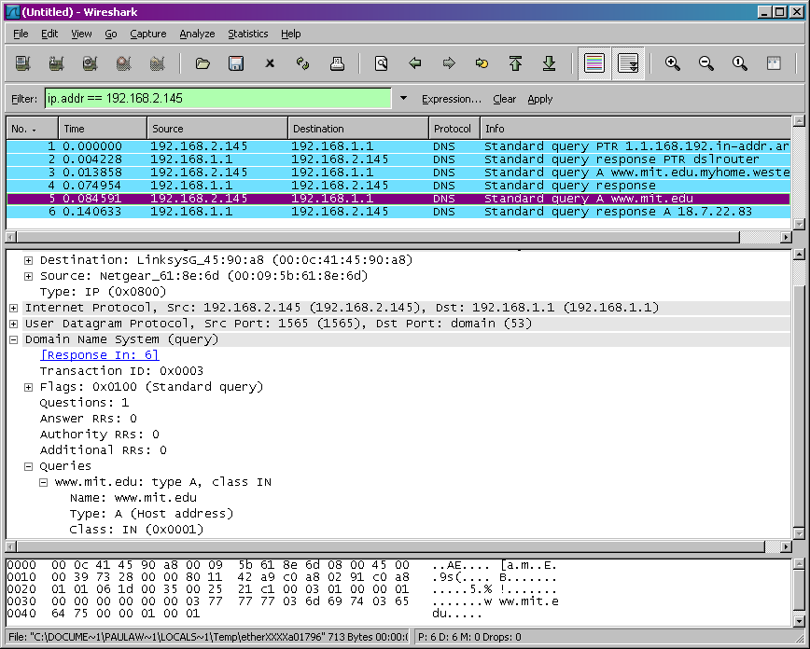

We see from the above screenshot that *nslookup* actually sent three DNS queries and received three DNS responses. For the purpose of this assignment, in answering the following questions, ignore the first two sets of queries/responses, as they are specific to *nslookup* and are not normally generated by standard Internet applications. You should instead focus on the last query and response messages.

1. What is the destination port for the DNS query message? What is the source port of DNS response message?

**The destination port for the DNS query message is 53 and the source port of the DNS response message is also 53.**

1. To what IP address is the DNS query message sent? Is this the IP address of your default local DNS server?

**The DNS query message was sent to 192.168.1.1. This is also the same IP address of my default local DNS server.**

1. Examine the DNS query message. What “Type” of DNS query is it? Does the query message contain any “answers”?

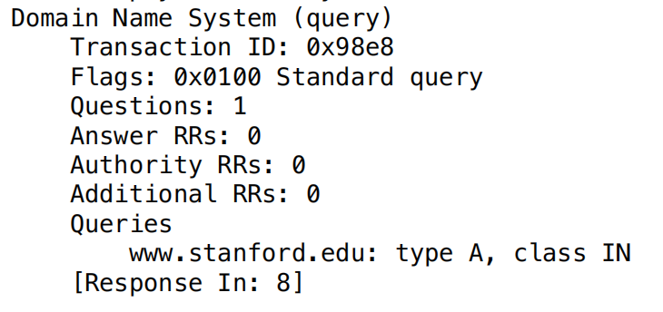

**The DNS query message is of “Type A” and it does not contain any answers.**

1. Examine the DNS response message. How many “answers” are provided? What do each of these answers contain?

**There are 2 answers provided in the DNS response message. The answers contain a Name, Type, Class, Time to live, Data length, CNAME(for the first answer), and Address (for the second answer).**

1. Provide a screenshot.

**Standard Query:**

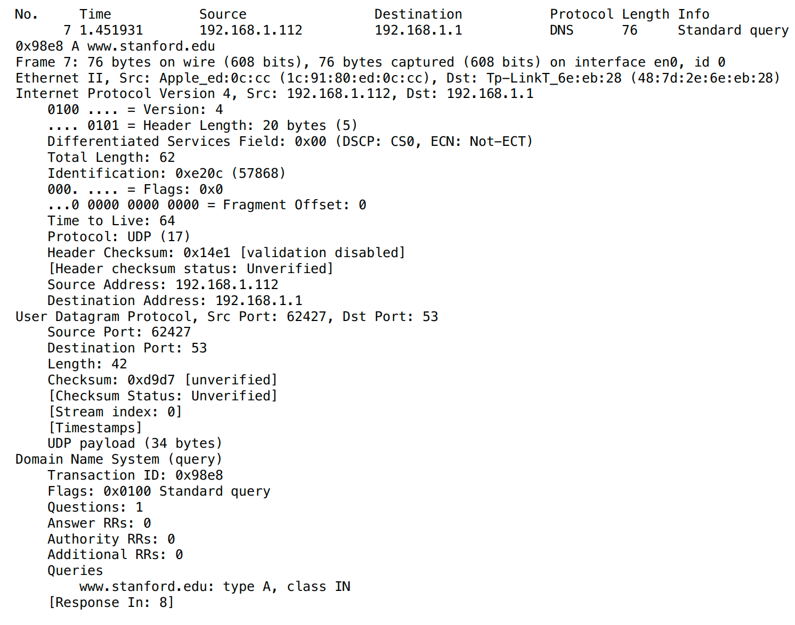

**Response:**

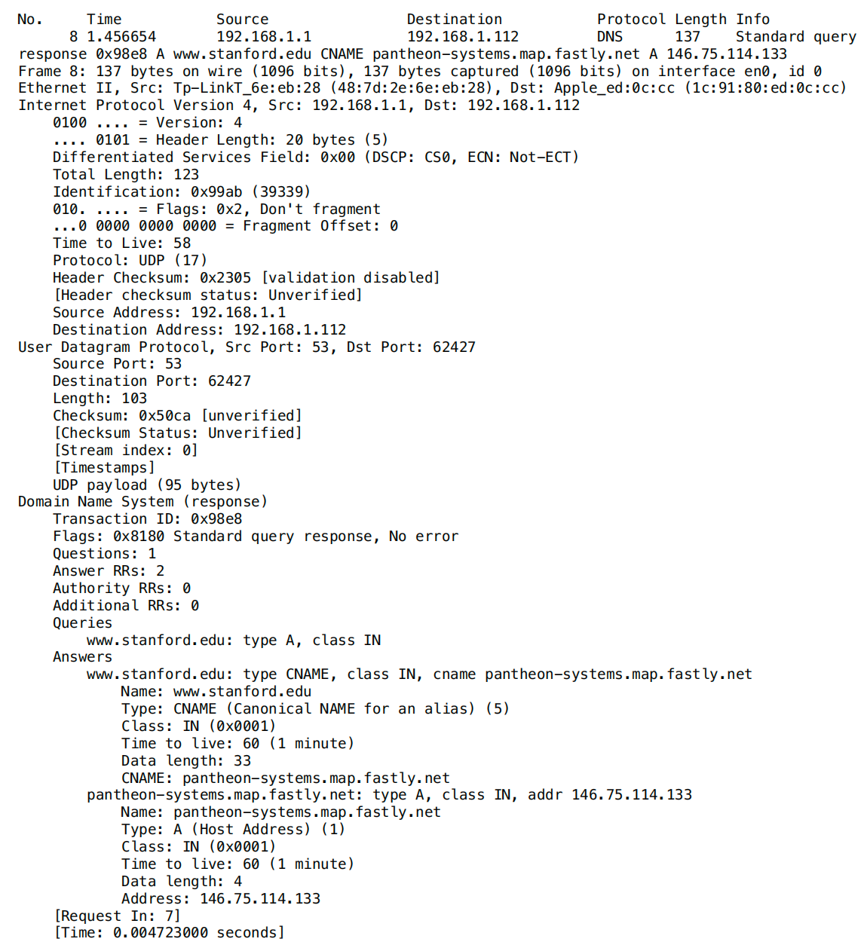

Now repeat the previous experiment, but instead issue the command:

nslookup –type=NS stanford.edu

Answer the following questions:

1. To what IP address is the DNS query message sent? Is this the IP address of your default local DNS server?

**The DNS query message was sent to the IP address 192.168.1.1 and this is also the IP address of my default local DNS server.**

1. Examine the DNS query message. What “Type” of DNS query is it? Does the query message contain any “answers”?

**The DNS query message is of “Type NS” and it does not contain any answers.**

1. Examine the DNS response message. What Stanford nameservers does the response message provide? Does this response message also provide the IP addresses of the Stanford name servers?

**The DNS response message provides the following nameservers:**

atalante.stanford.edu

argus.stanford.edu

ns7.dnsmadeeasy.com

avallone.stanford.edu

ns5.dnsmadeeasy.com

ns6.dnsmadeeasy.com

**No, the response message does not provide the IP addresses of the Stanford name servers.**

1. Provide a screenshot.

**Standard Query:**

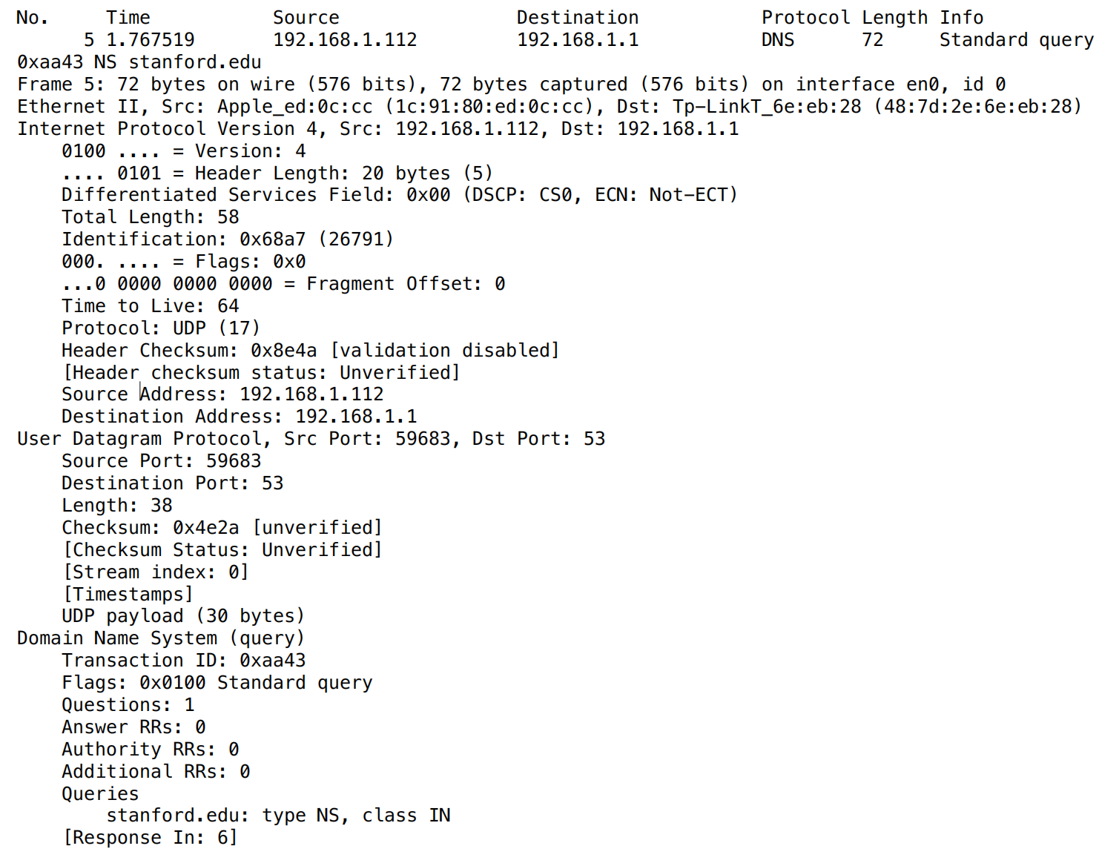

**Response:**

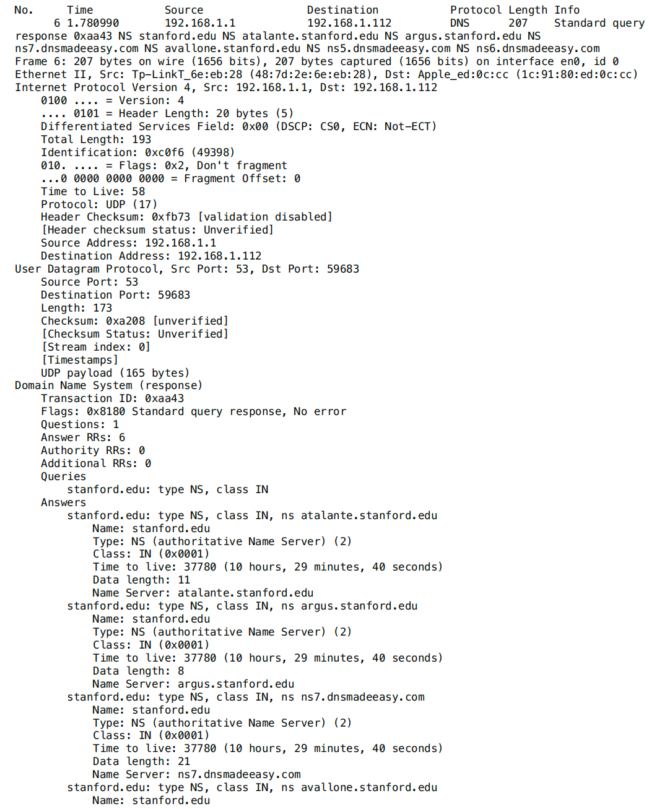

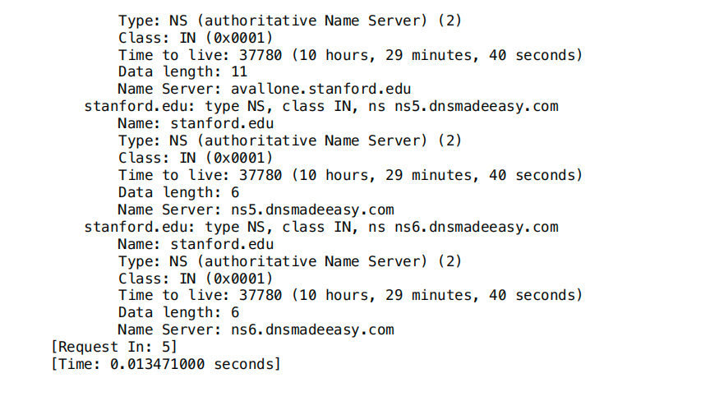

Now repeat the previous experiment, but instead issue the command:

nslookup cs.stanford.edu argus.stanford.edu

Answer the following questions:

1. To what IP address is the DNS query message sent? Is this the IP address of your default local DNS server? If not, what does the IP address correspond to?

**The DNS query message was sent to the IP address 171.64.7.115. It is not the IP address of my default local DNS server. It corresponds to argus.stanford.edu’s server IP address.**

1. Examine the DNS query message. What “Type” of DNS query is it? Does the query message contain any “answers”?

**The DNS query message is of “Type A” and it does not contain any answers.**

1. Examine the DNS response message. How many “answers” are provided? What does each of these answers contain?

**In the DNS response message, 1 “answer” is provided. It contains a Name, Type, Class, Time to live, Data length, and Address.**

1. Provide a screenshot.

**Standard query:**

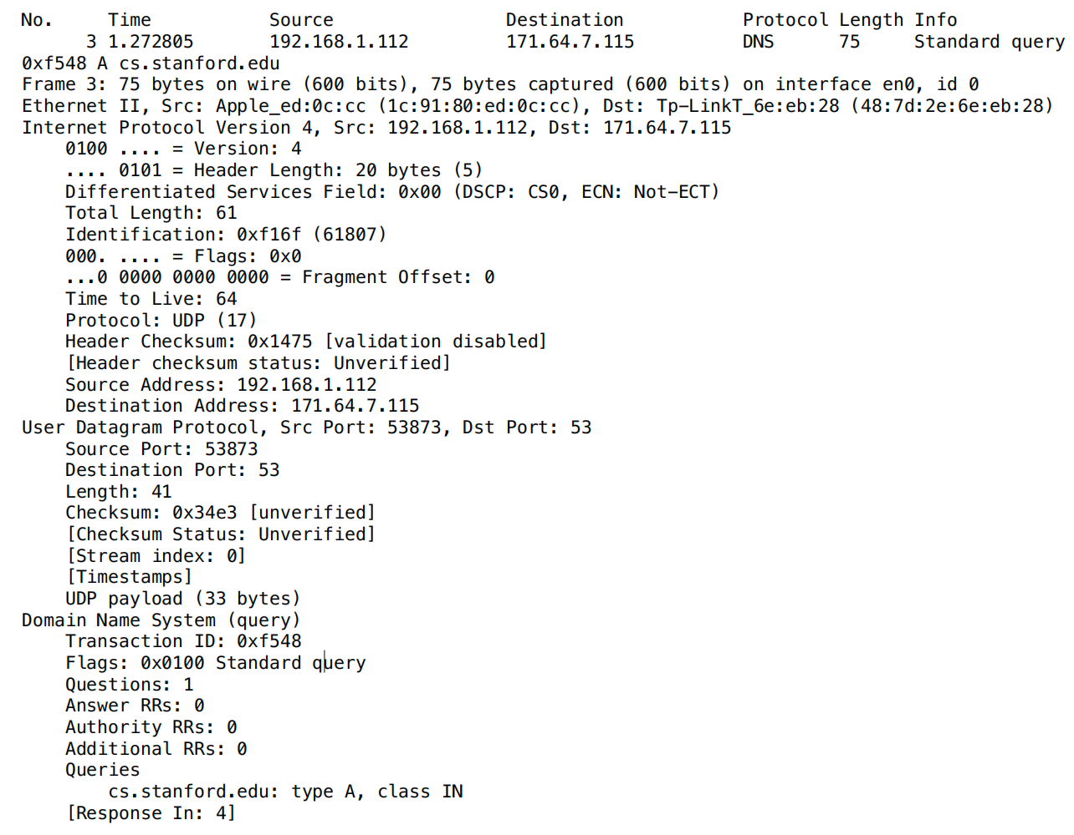

**Response:**

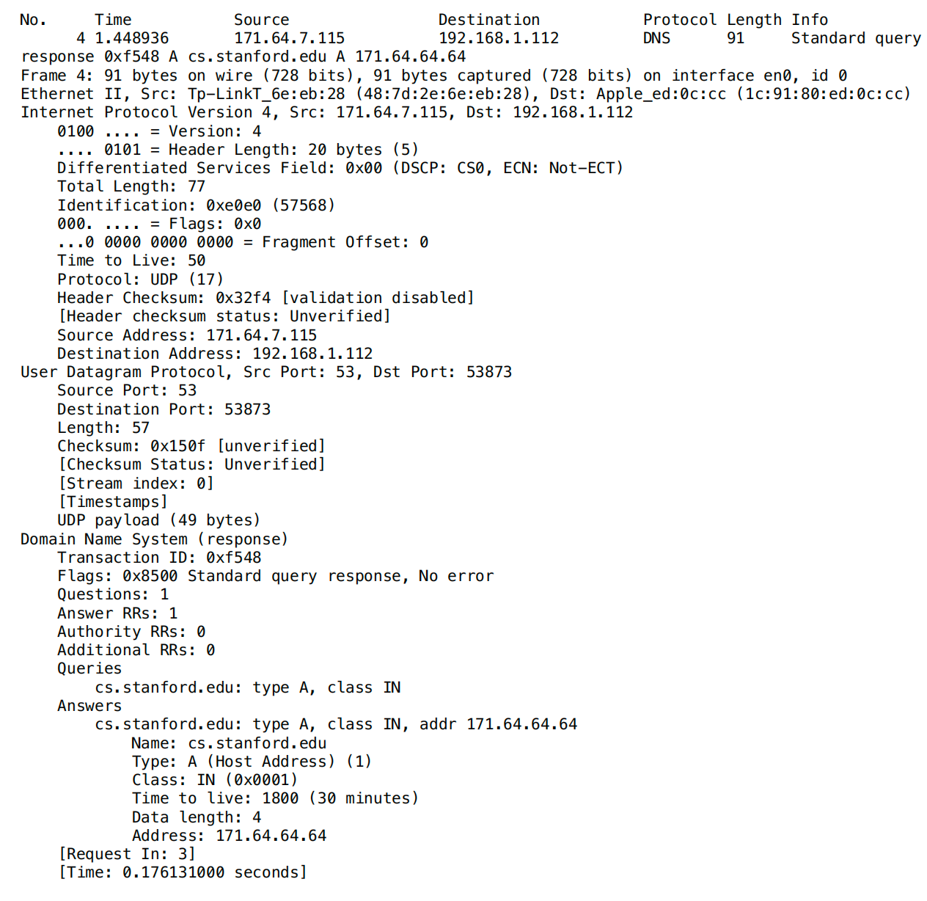

1. What do we mean by “annotate”? In your lab report, please highlight where in the printout you’ve found the answer and add some text (preferably with a colored box) noting what you found in what you ‘ve highlight and annotate.